# Requirements

**BRAINSTORMING IDEAS**

https://miro.com/app/board/o9J_kjKpWic=/

## Introduction

**The purpose of the requirements phase is to allow for developers to work out what the application should be able to do. It is important to understand what the users would like the application to do rather than the developer deciding what is required.**

**You can write a bit about your project area. Each paragraph has a blank line between it and the previous paragraph**

The game we are developing is “Animal Simulator”. It has 3 main genres: open world, sandbox, and simulation. For now, we will keep the game single player because it is less complex and more feasible given the amount of time we have. Multiplayer will require a lot of networking technologies and more coding.

We will be using low-poly graphics because they aren’t that graphics intensive and besides, they are nice to look at. The models have less polygons and they are grouped in a mesh together, creating a cartoonish look with different shapes. Pastel colours, deep blacks, and vibrant colours work well with this graphics style.

The game doesn’t have a story, because in most cases, sandbox games focus more on independence, freedom, and creativity. However, the game has objectives and unlockables, so it will give the player some sense of achievement and something to strive towards. For example, if they get a certain amount of points, a message will appear onscreen that will compliment and praise the player. The player will be able to unlock new skins or even new animal.

|  |  |
| --- | --- |
| PICTURE | PICTURE |
| PICTURE | PICTURE |

## Requirements gathering

### Similar applications

**Look at and document three similar applications. Be sure to include the following for each:**

GAME 1 - GOAT SIMULATOR

* **Descriptions**

Reference: https://store.steampowered.com/app/265930/Goat_Simulator/

*“Gameplaywise, Goat Simulator is all about causing as much destruction as you possibly can as a goat. It has been compared to an old-school skating game, except instead of being a skater, you're a goat, and instead of doing tricks, you wreck stuff. Destroy things with style, such as doing a backflip while headbutting a bucket through a window, and you'll earn even more points! Or you could just give Steam Workshop a spin and create your own goats, levels, missions, and more! When it comes to goats, not even the sky is the limit, as you can probably just bug through it and crash the game.”*

* **+ Advantages / - Disadvantages**

Price

**+** You get exactly what you paid for. You can play as a goat.

**-** I think the price should be €4.99 instead of €8.19.

UI

**+** It’s nice and user-friendly.

**+** When you start the game, you’ll see the game title and the camera is moving around the world to show case the world.

**+** The colour scheme of the main menu matches the grass in the game. After all, goats eat grass.

**+** If you hover over the nav bar, they make some sounds and changes colours.

**+** I like how the nav bar is placed at the left side and when you click on let say Options, the Options screen placed on the right side and there’s space in the middle to showcase the game. The menu is also a little bit transparent.

**-** Nothing bad.

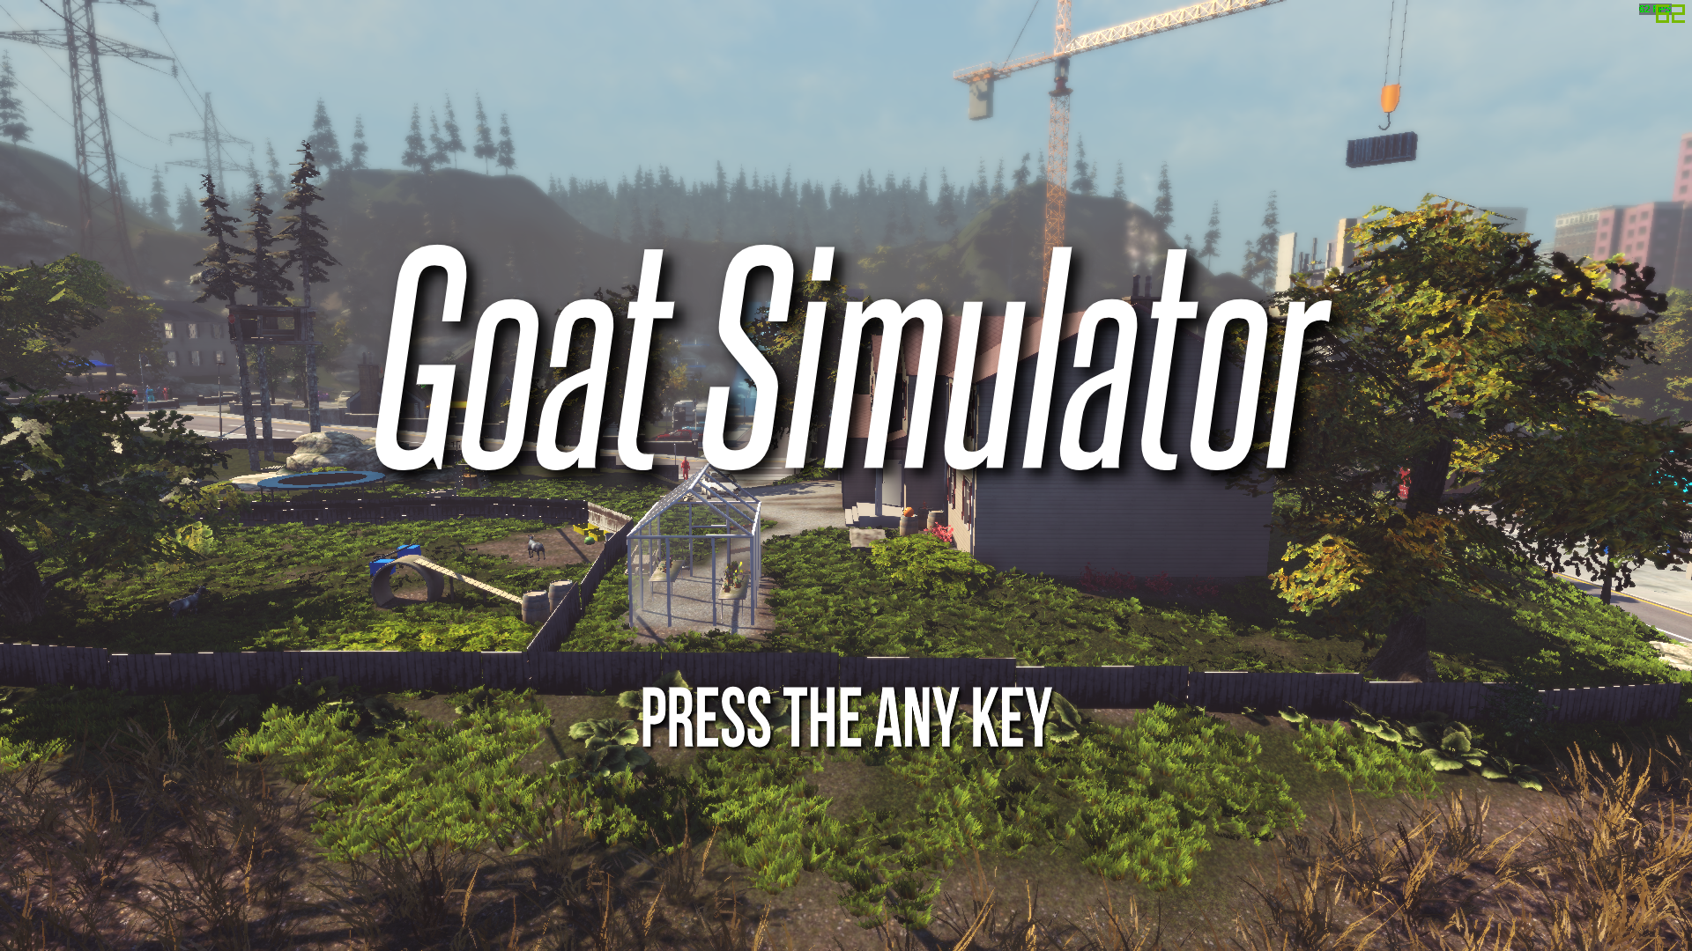 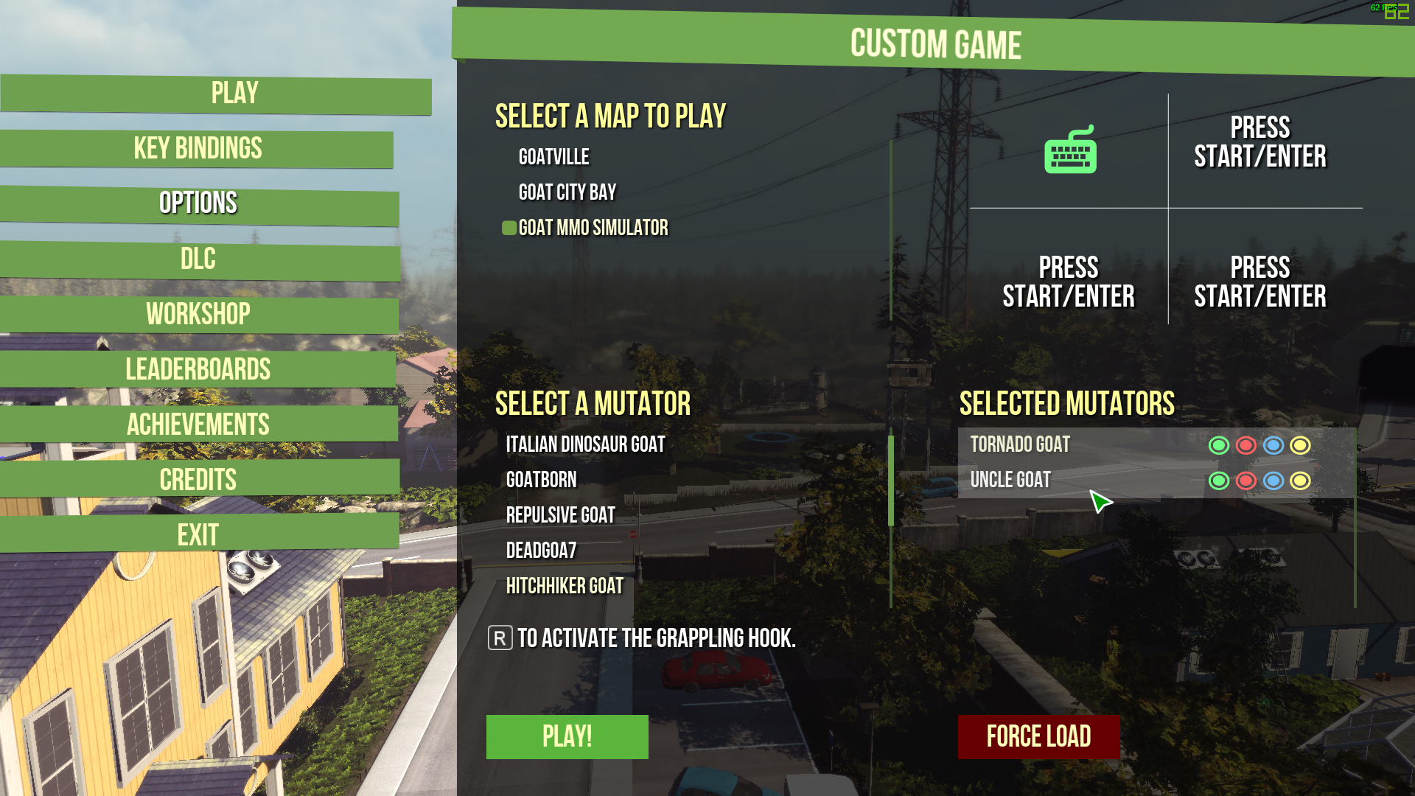

Graphics

**+** Nice looking graphics, trees have plenty of foliage, good lighting and nice texture on the rocks

**-** Not much to say, other than that the face of the goat looks weird and some of the AI’s faces looks like they’re from early 2000s graphics.

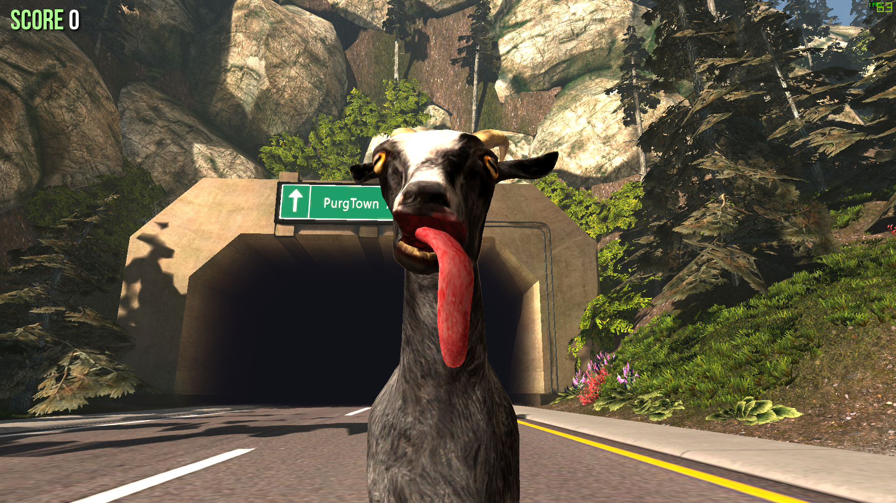 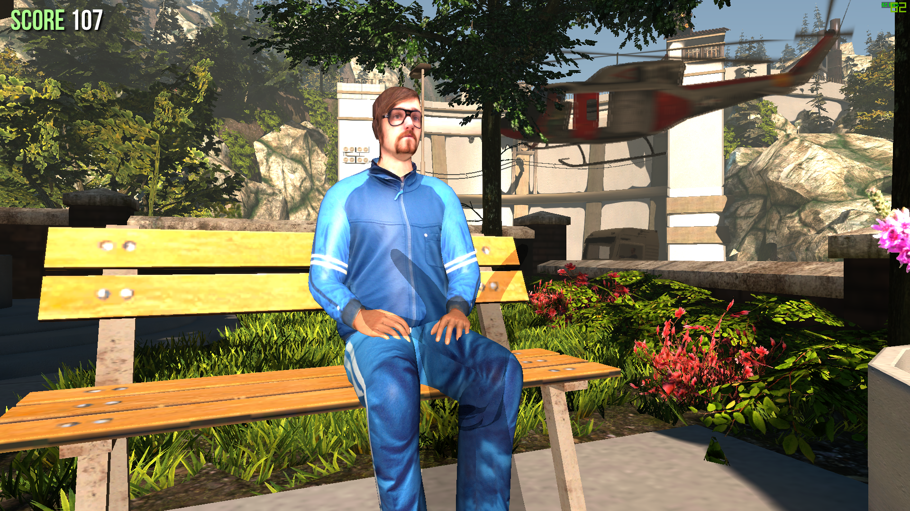

Gameplay / Mechanics

**+** The rag-doll effect makes everything look more satirical, and sillier.

**+** 3rd person mode allows the player to see what skins they have equipped.

**+** Fun gameplay that allows you to destroy as many things you want, and even sacrifice 5 people to Satan.

**+** Jump, walk, zoom in and out with the camera, make goat noises and use your tongue to grab things.

**-** The ragdoll and gravity can sometimes launch you somewhere and it’s easy to get stuck.

**-** There are bugs; however, they are intentional to make the game sillier.

**-** It gets boring quickly.

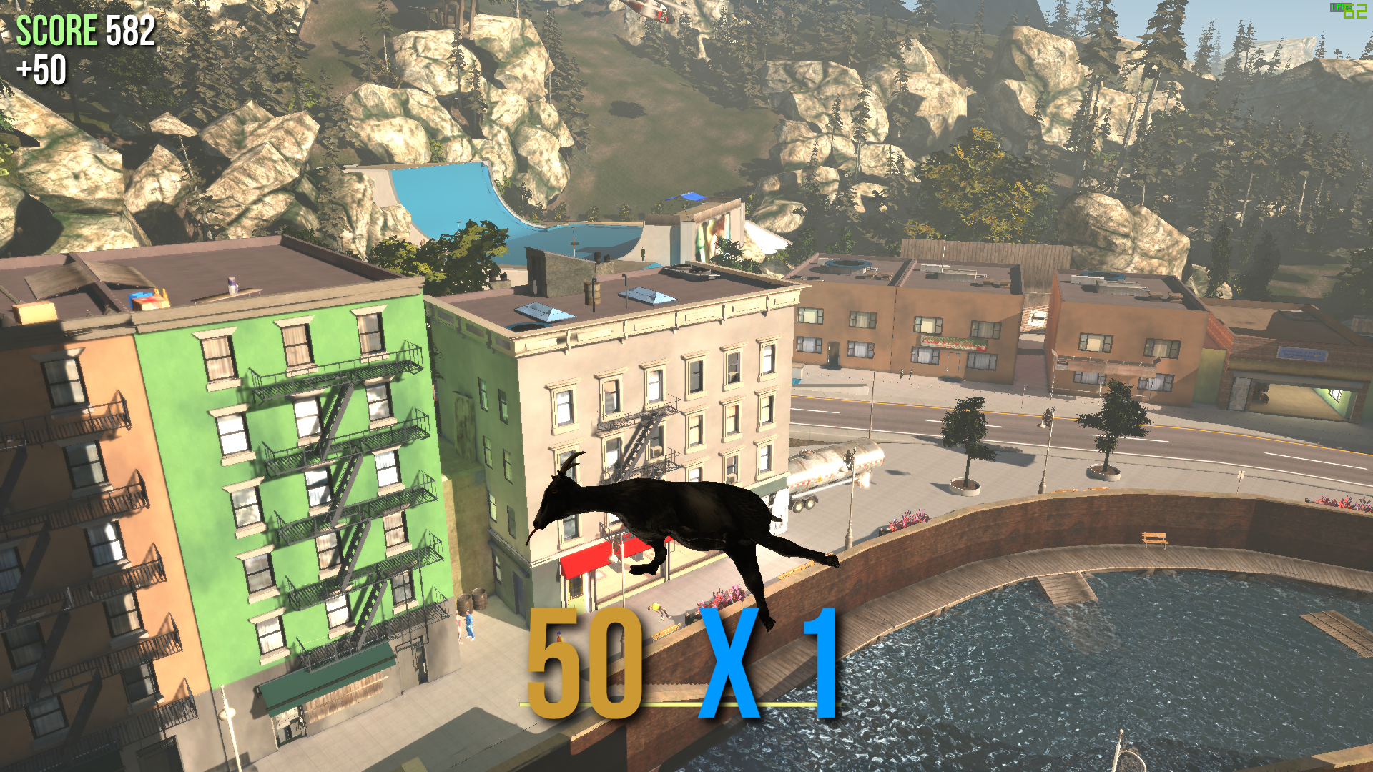 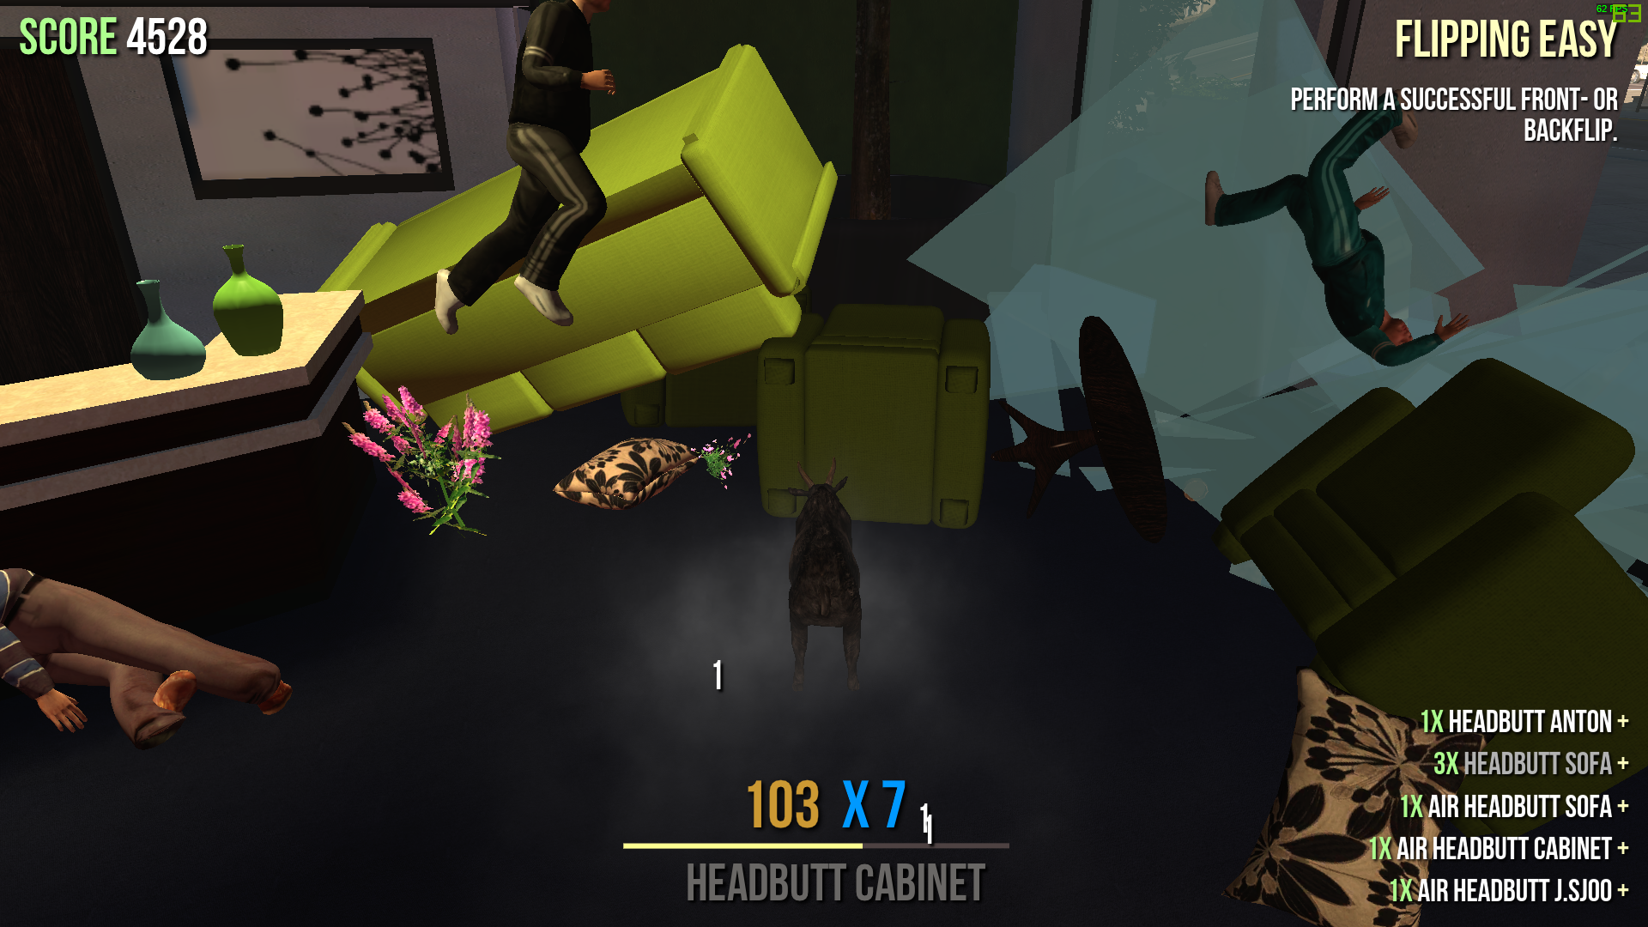

Level Design

I don’t think there is any. If the player gets a certain amount of points, they can unlock skins. The perspective of the player is in 3rd person mode, so the player can see what skins they have equipped after unlocking them. It also allows you to see how silly the goat’s movement looks.

Objectives

**+** Express your freedom, creativity and independence.

**+** Quests and achievements to unlock more stuff like skins, and to go into different maps.

**+** Mini games such as racing.

**-** Nothing much to say.

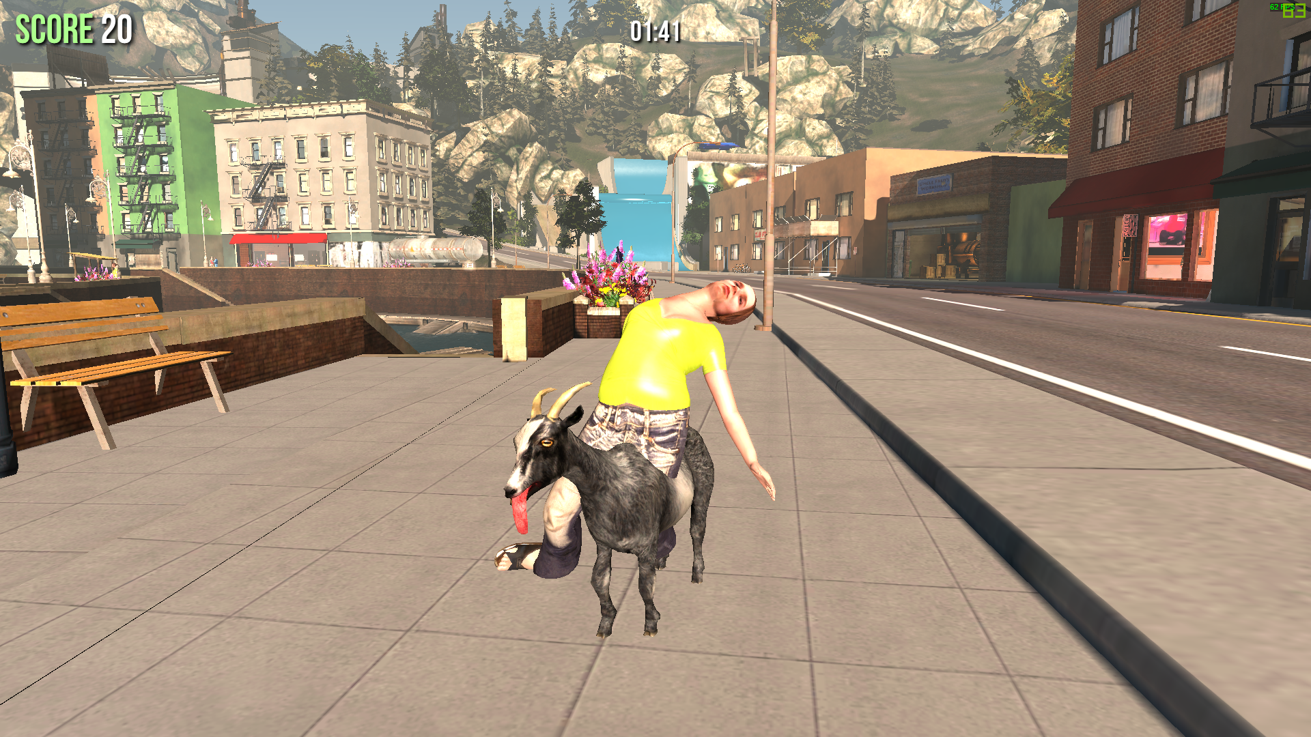 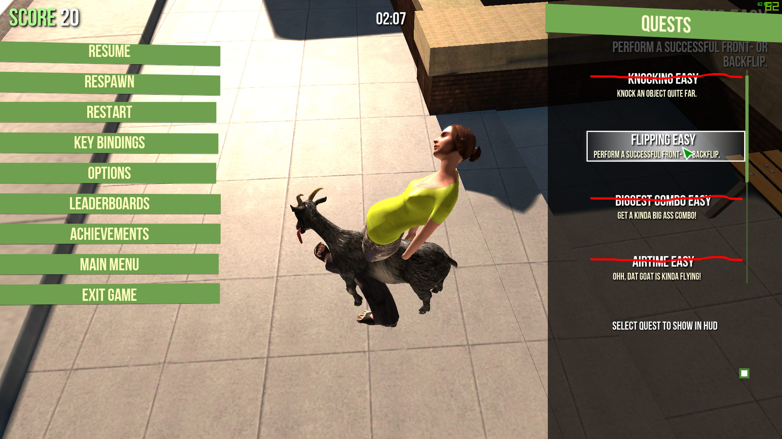

Multiplayer/Singleplayer

**-** There is no multiplayer, but it would be fun if there were other goats in the world. Imagine 4 goats destroying the whole world. Jeez!

Sound

**+** Silly indie ukulele music with a trumpet to make it sound sillier.

AI

**+** People will notice you and run away from you if you destroy stuff.

**-** Not that realistic, but sufficient.

Replay Ability

It’s replay-able in short sprints, but I don’t think I’d be able to play it everyday for hours and hours.

GAME 2 – THE ISLE

* **Descriptions**

REFERENCE: https://store.steampowered.com/app/376210/The_Isle/

*“The Isle is intended to be a gritty, open-world survival horror game. Explore vast landscapes of dense forest and open plains, traverse treacherous mountains, and wade through dark swamps where horrors lurk. Hidden within are ruins that hold insight as to what came before. Through it all, keep in mind there is only one goal: survive.”*

* **+ Advantages / - Disadvantages**

UI

**+** Nice looking main menu. The moss around it and that stutter screen gives it a Jurassic Park feel.

**+** The game is showcased from different camera angles.

**+** The HUD is dynamic, but can be set to static.

**-** The camera angles and the tablet could initially make the wrong impression. I thought it would be like Jurassic Park and that I’m an animal expert hunting or examining dinosaurs.

**-** Limited hints don’t tell you how to make eggs or make a burrow.

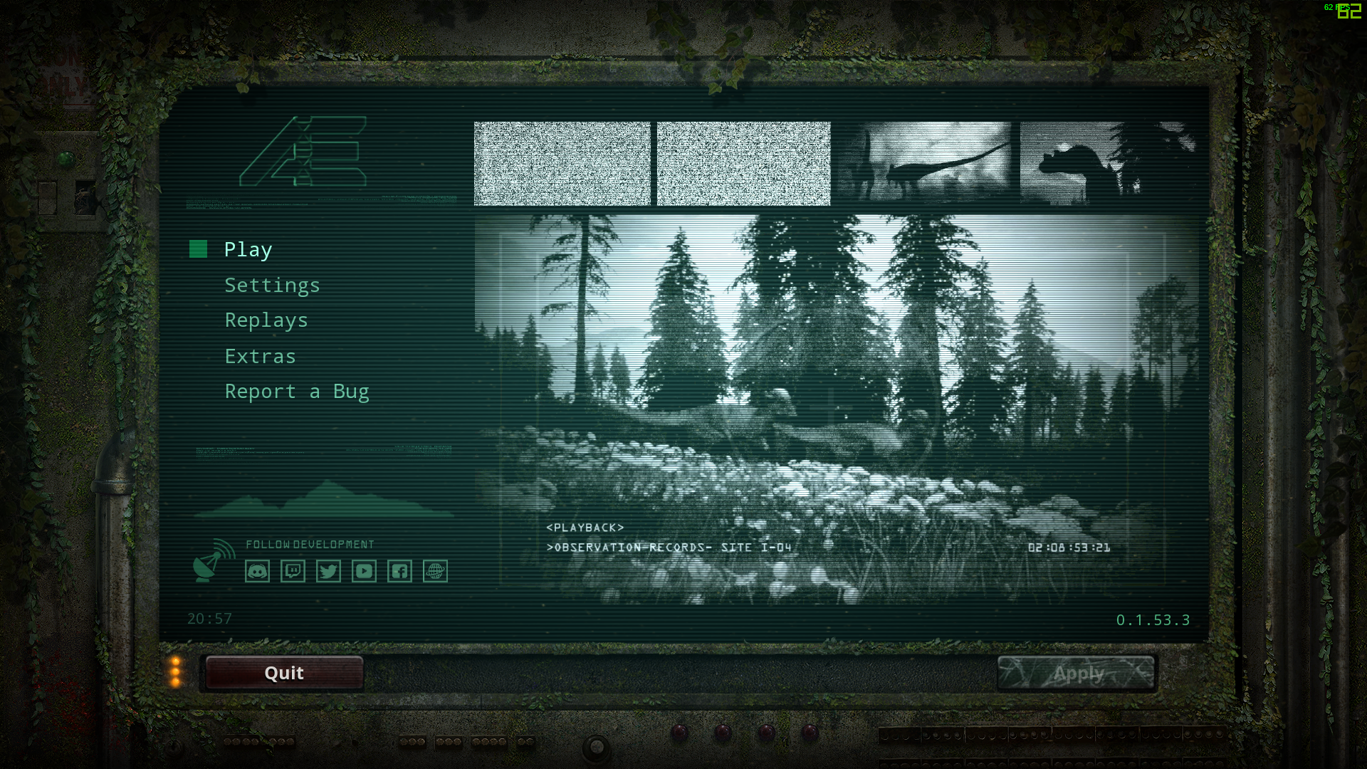 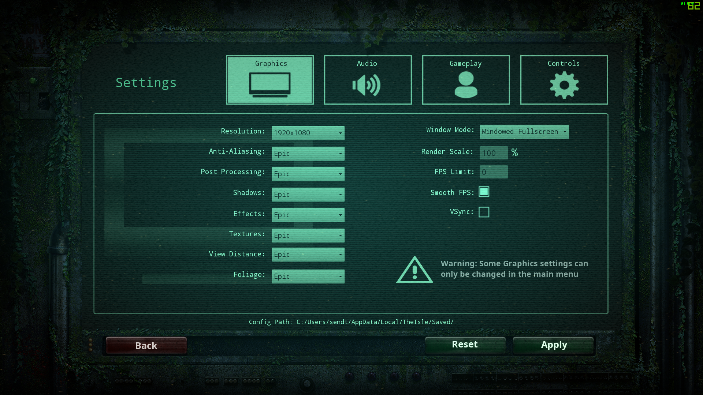

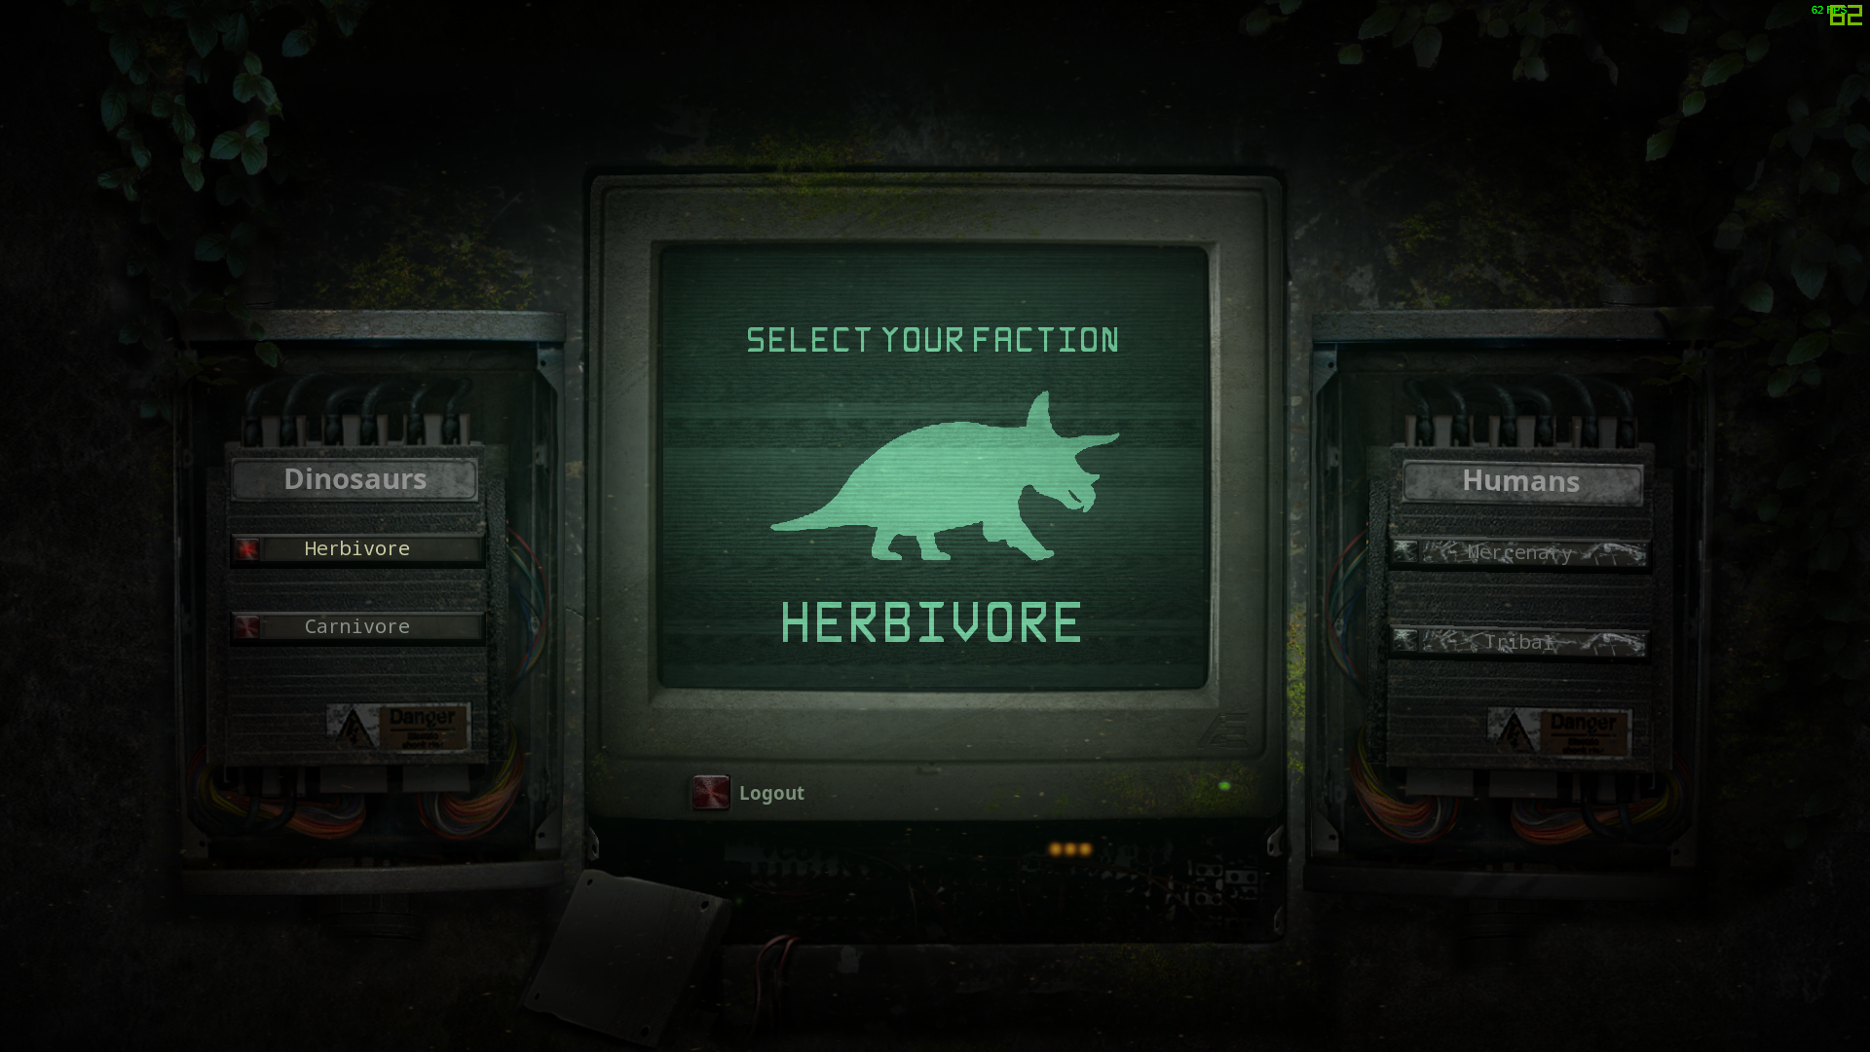 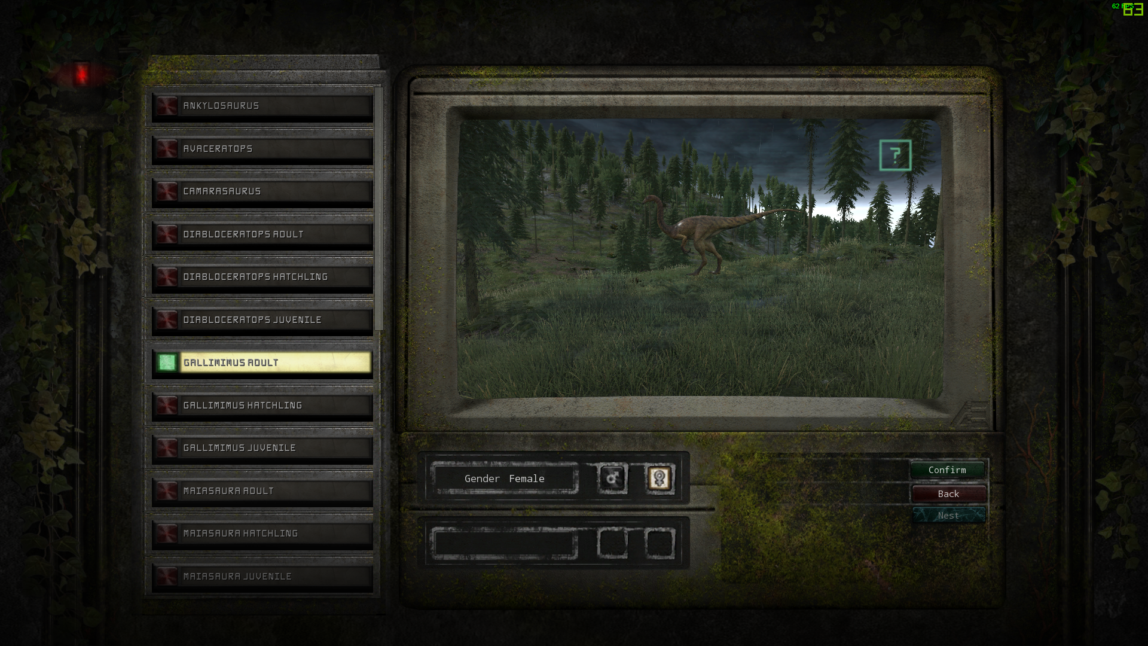

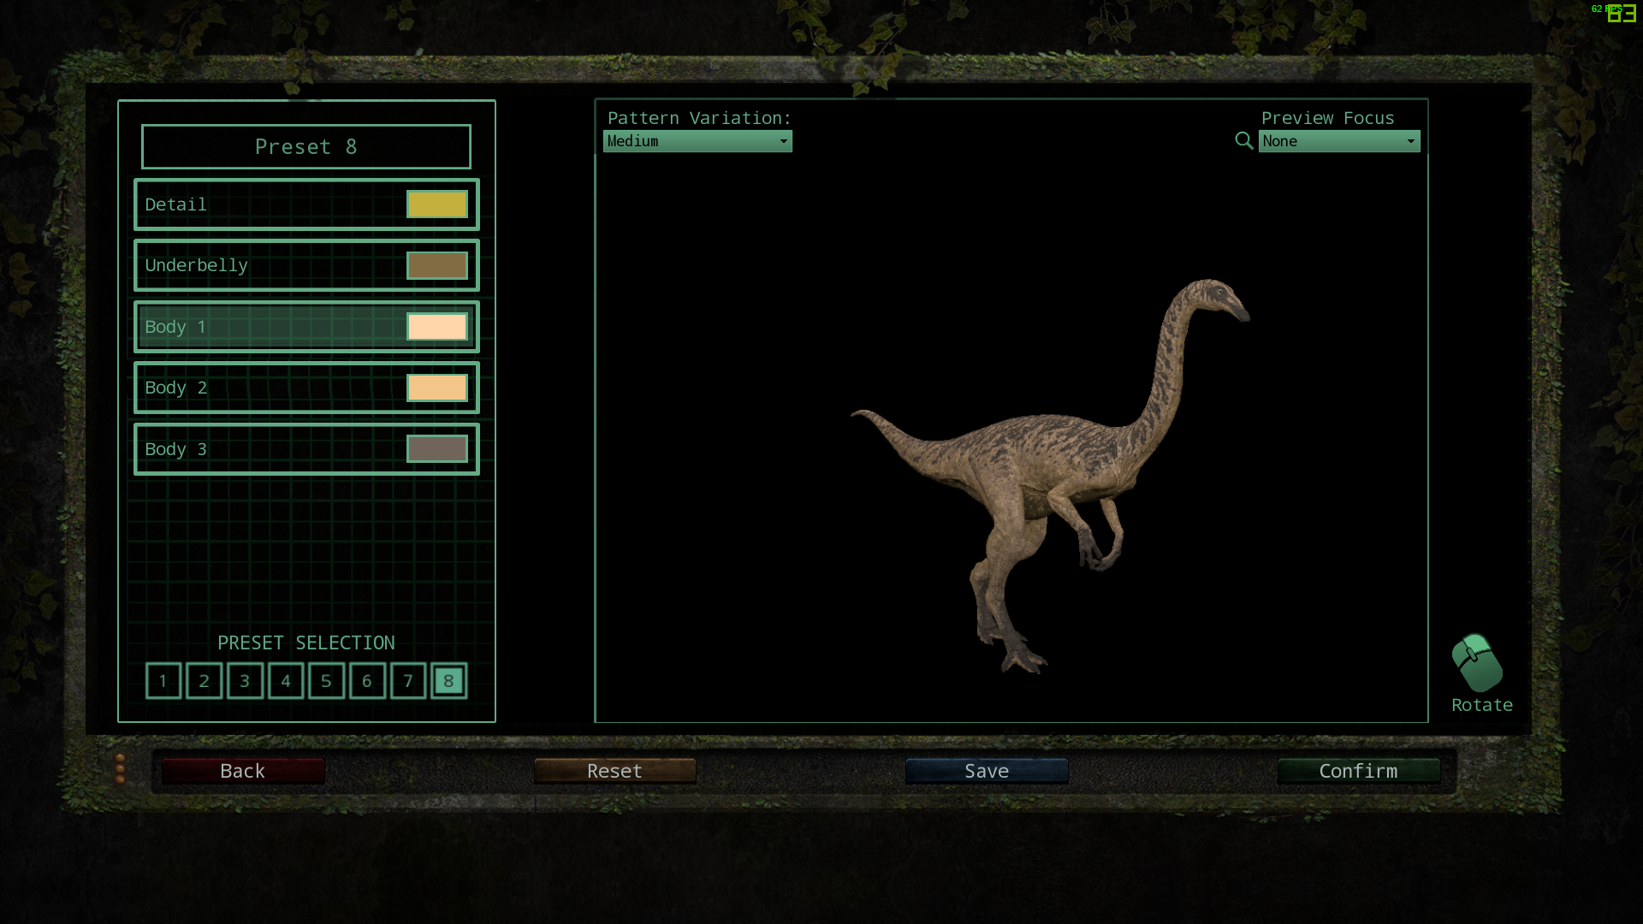 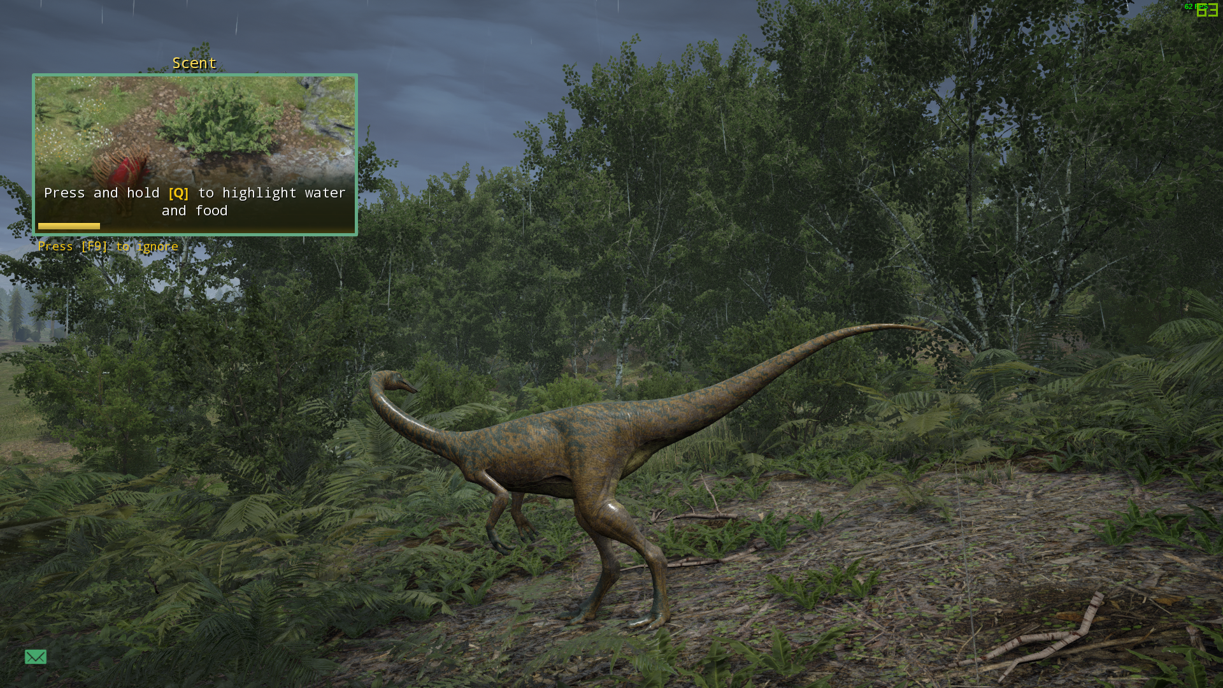

Graphics

**+** Ability to change the dinosaur screens make it more realistic.

**+** Beautiful scenery and trees have good foliage.

**+** Screen is dark during the night time, which is of course realistic.

**-** Nothing bad to say.

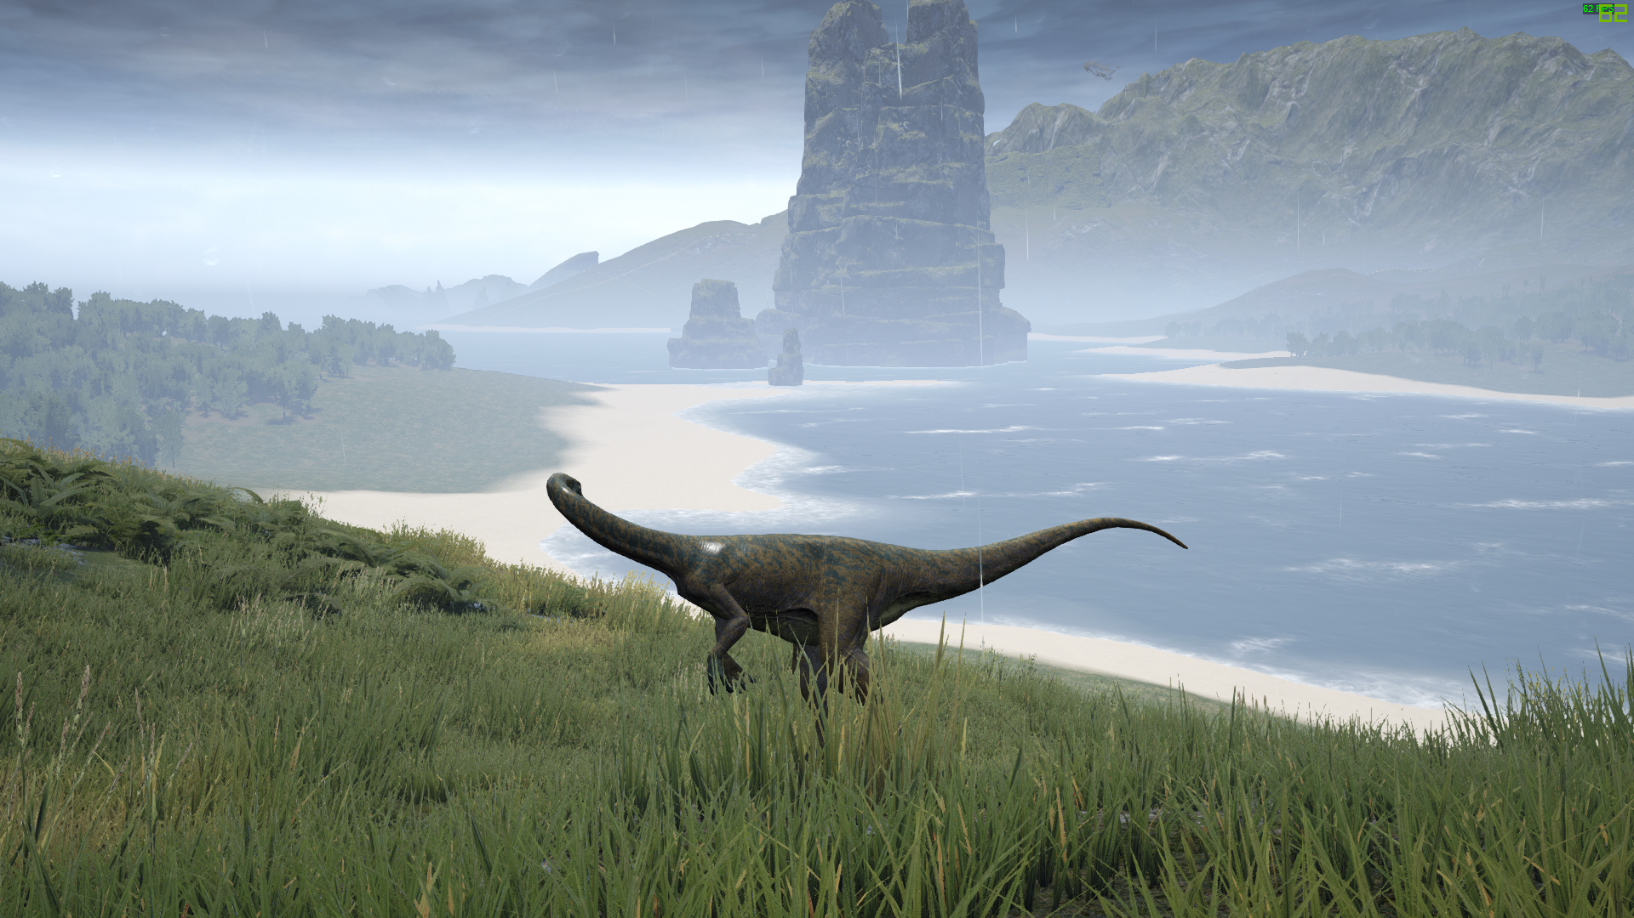 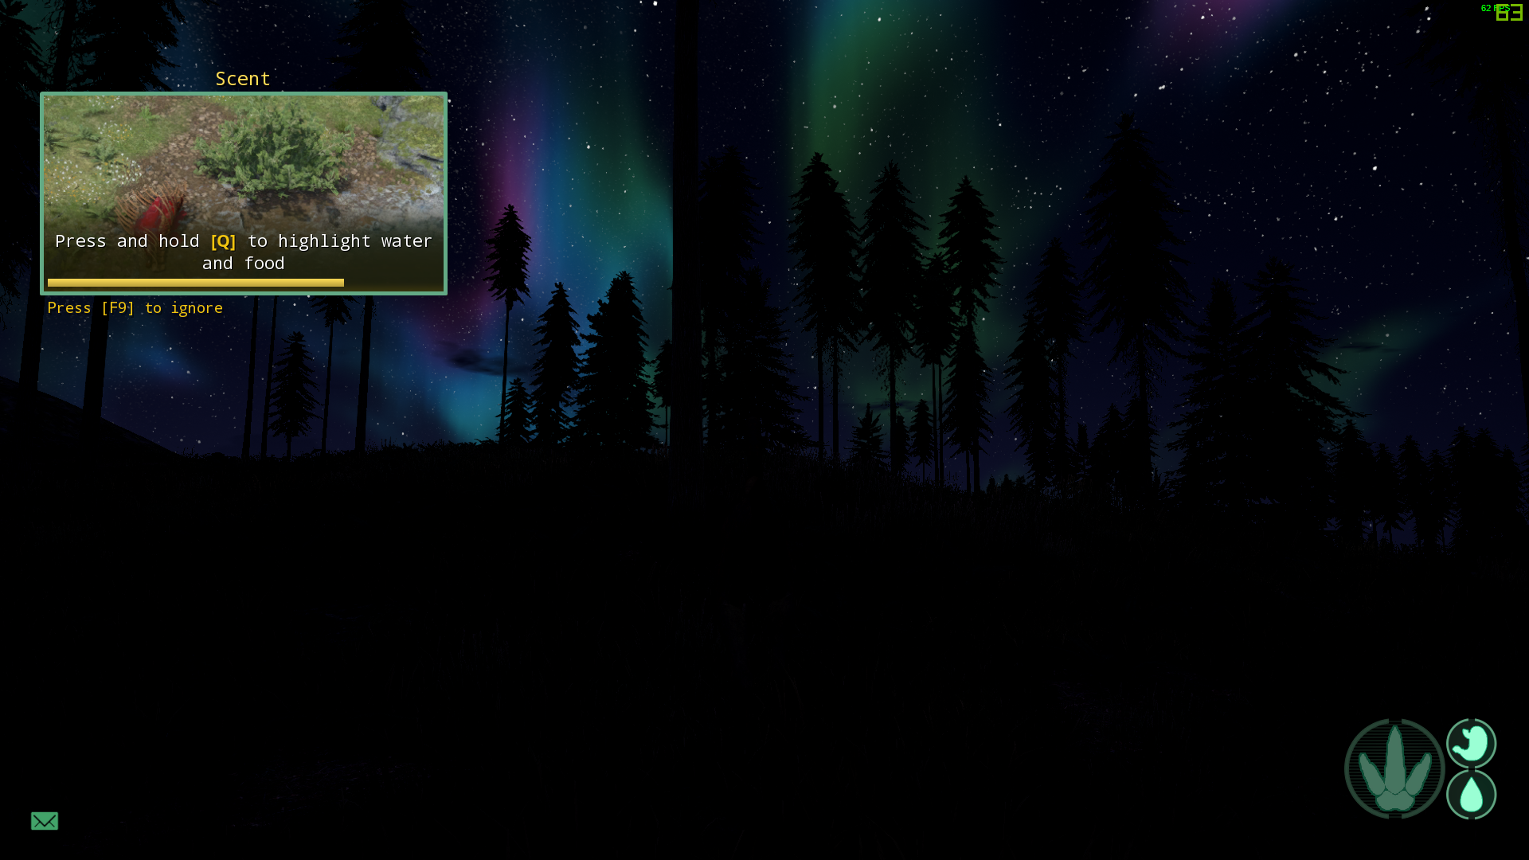

Gameplay / Game Mechanics

**+** Select different dinosaurs and change the skin patterns.

**+** Join servers and chat with other players.

**+** Jump, walk, crouch, eat, drink, make dinosaur noises, make babies, and make a home.

**+** Fall damage causes broken bones.

**+** You can die, attack and kill other dinosaurs.

**-** The game doesn’t give you hints on how to make a home or make babies.

Level Design

**+** It focuses on survival and PVP.

**+** Landscapes and environments are rendered in a realistic style.

**+** Game field has an open-world feel due to its large size.

**+** Very nice ambient sounds of nature.

**+** Each dinosaur has unique sounds e.g. one sound for calling others, another sound for warning others.

**-** Nothing bad to say.

AI

**+** The AI are quite smart and carnivores will hunt and attack you if you’re a herbivore.

Objectives

**+/-** The main objective is if the player is a baby dinosaur, they must grow by eating and drinking water. Then they make a nest, have babies, and help them survive. If they die, they can play as another baby.

Multiplayer/Singleplayer

**+** Ability to create and host your own server, and add mods.

**+** Option to filter out server and map settings.

**+** Global, local, team and group text chat.

**-** There is no single player. Several players have expressed interest in a single player mode.

**-** Heavily focuses on PVP and not everybody likes PVP; some would rather play in a PVE server.

**-** Slow server search. Game mode should have a drop-down menu instead of a placeholder.

**-** Very limited official servers.

**­-** No voice chat.

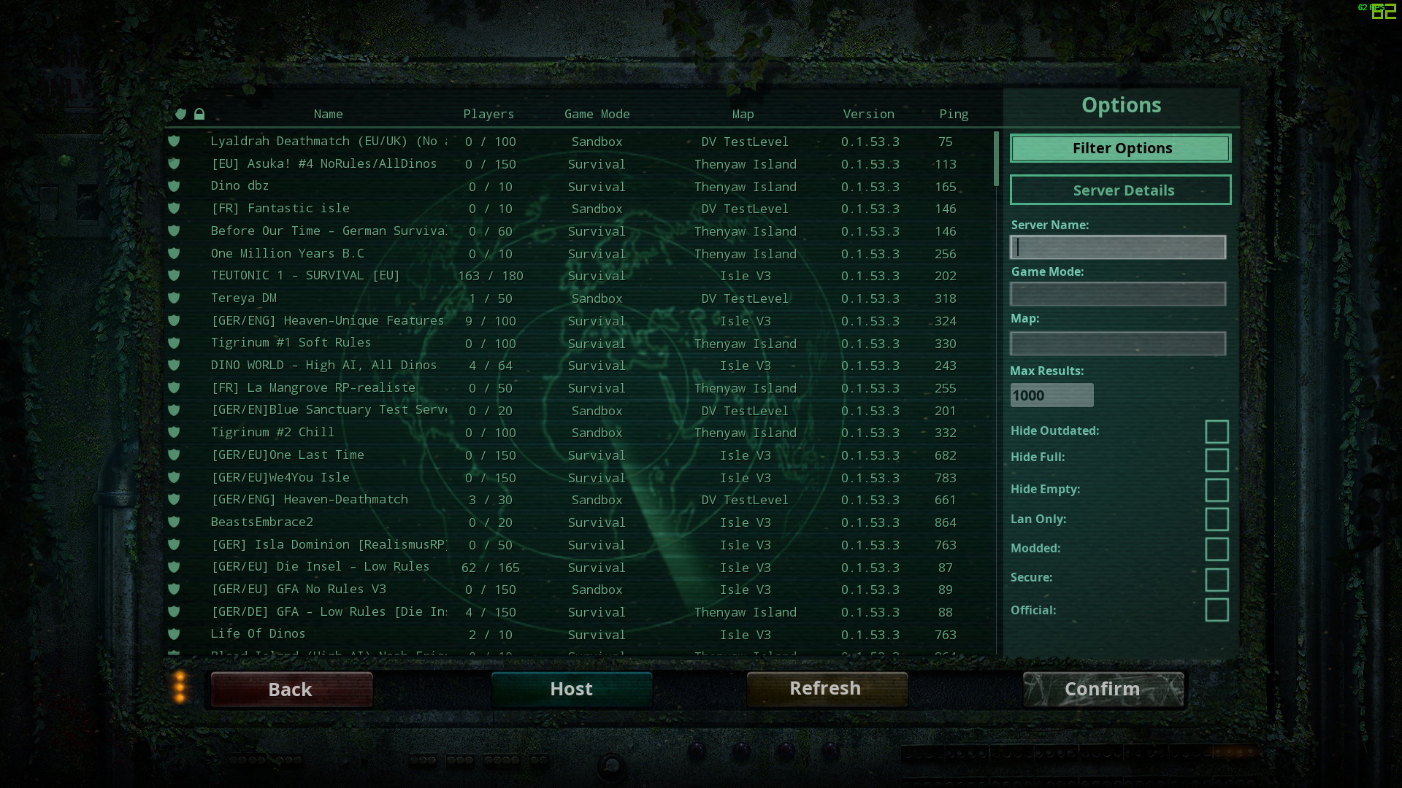 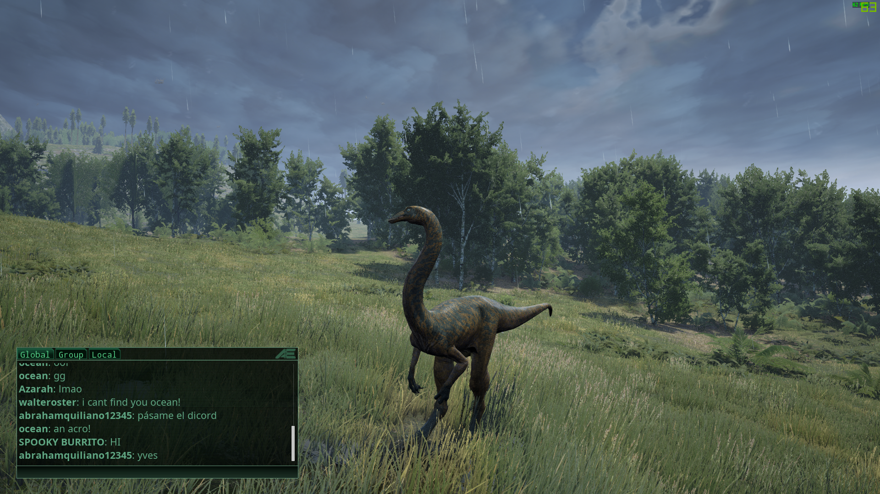

### Personas

These are fictional characters to help the developer understand the users’ needs. They also help identify who the relevant users are.

For reference and to get ideas:

<https://medium.com/@fernandocomet/the-player-persona-template-d171e3e0c05d>

<https://www.myersbriggs.org/my-mbti-personality-type/mbti-basics/judging-or-perceiving>

This website was used to create personas:

[https://www.hubspot.com/make-my-personahttps://assets.weforum.org/editor/large_f521kcO6KWMHIuWbejh1UG8FKygKJkKiwUY4FLtotsg.JPG](https://www.hubspot.com/make-my-persona)

**Persona 1:** Sandbox Gamer

**Persona 2:** OpenWorld Gamer

**Persona 3:** Simulator Gamer

What kind of player are you?

I like being the hero and do the good things, but not because you have to do them by law

If nobody gets hurt I don't to follow the law

I don't want to enforce rules on anybody

I don't compete in games, I am being cooperative

I like to build a lot of things

I like long games

I like most games that has good replayability and make your own stuff

Motivation:

What motivates you

Gender Male

Age 25

Status Single

Job Title Working for McDonalds

Industry Retail, fastfood

Location Wicklow

Gamers for OpenWorld Sandbox Games

Personality:

Extrover Introvert 4

Sensing Intuitive 4

Thinking Feeling 1

Judging Receiving 4

### Interviews ✓ 9/10/2020

Conduct interviews with 3 or 4 users to find out what the important features for them for the app are. There may be various issues that arise in multiple interviews. These can be grouped together into several themes.

We asked 2 other classmates who are developing a fps parkour game.

Questions 1:

Answer:

### Survey ✓ 12/10/2020

You can create a questionnaire and use the results of the questionnaire as a basis for finding out requirements.

Finding out the requirements for our game:

<https://forms.gle/NBuTSXrZnVfgFXjN8>

Finding out the target audience + creating personas:

https://forms.gle/a7r6WCRBq3PgQ4Uv9

## Requirements modelling

### Functional requirements

Create a numbered list of what the application should be able to do. Start with the most important feature.

TOP 10 Features + brief description:

1. Sandbox:
2. Open World:
3. Points System:
4. Choose your animals:
5. Visual descriptions:
6. Stats:
7. Game logs:
8. 3rd person:
9. Collectibles:
10. Achievements:

### Non-functional requirements

These are requirements which if not met do not stop the application from working, but which mean that the application is not working as well as it should. They are usually based on issues such as:

* Usability

**Talk about potential bugs and problems (make references to the other games)**

* Performance

**Talk about performance requirements.**

Smoothing

**Is it resource intensive?**

We are aiming to make it playable for mid-range gaming PC, or mid-range mobile devices.

**What platform will it run on e.g. mobile/pc?**

PC, maybe mobile too

* Security

**Will it require user credentials?**

You can enter your name

**Is there a login system?**

No asdasda

**Is there auto-save and where will it be saved?**

Yes asdsadia

### Use Case Diagrams

Consists of actors and use cases. You should document each individual use case.

??????????????????????????????????????????

## Feasibility

This section describes which technologies are planned to be used in the development of the application. It then explains if there are any issues in terms of the technical feasibility of the project, for example, if there are two different types of software which may have compatibility issues.

TOP 5 TECHNOLOGIES:

1. Unity for game development:

asdaasdasdasd

1. Visual studio code for coding:

asdasda

1. Miro for brainstorming:

asdasdasd

1. Trello for project management:

asdadasda

1. Photoshop for designing:

asddsadsa

1. Possibly blender:

asdasdadasds

## Conclusion

Write a couple of paragraphs summing up the chapter. Explain what area your project is about. Describe what the chapter has discussed.

??????????????????????????????????????????

Figure 1 <https://braveintheattempt.com/2017/10/30/google-forms-game-based-learning/>

**IDEAS:**

<https://www.linkedin.com/learning/unity-2017-architectural-visualization/creating-a-standard-third-person-character>

<https://www.linkedin.com/learning/unity-2017-architectural-visualization/swapping-third-person-characters>

<https://assetstore.unity.com/packages/3d/animations/basic-motions-free-pack-154271>

<https://www.youtube.com/watch?v=IJdidB83aig>

<https://www.youtube.com/watch?v=c4HDfO2W1Nc&t=250s>

https://www.youtube.com/watch?v=4HpC--2iowE&t=1035s